PROJECT REPORT
Drone Project Report
Assembly, Configuration, Calibration and Flight Testing of a Quadcopter Using Pixhawk
Project at a glance
Item | Details
Flight controller | Pixhawk 2.4.8
Airframe | Quadcopter: 4 × A2212/13T 1000 KV motors, 4 × Cyclone 35 A ESCs, 10-inch propellers
Radio system | FlySky FS-i6S transmitter, FS-iA10B receiver (PPM)
Navigation | GPS module with external compass
Power | 3S battery, 5200 mAh (as reported)
Software | Mission Planner
Flight modes | Stabilize, Loiter, Return to Launch (RTL)
Submitted by: ______________________________
Guide / Supervisor: ________________________
Date: ______________________________________
Prepared from the project assembly and testing notes

Abstract
This report documents the complete build of a quadcopter around a Pixhawk flight controller, from soldering the main plate to the first test flights. The work covered mechanical assembly, electrical wiring of four BLDC motors and 35 A ESCs, installation of a GPS module and a FlySky FS-i6S / FS-iA10B radio link, and ESC and motor-rotation checks. In Mission Planner the firmware was installed and the accelerometer, compass and radio were calibrated, the battery monitor was set up, and three flight modes (Stabilize, Loiter and RTL) were assigned to a transmitter switch.
The report presents each stage as a numbered step, supported by flowcharts, wiring and layout diagrams and summary tables. It closes with safety precautions, a troubleshooting guide and a list of items to verify before final submission.

Contents
1. Introduction 3
2. Objectives 3
3. System Overview and Working Principle 3
4. Components and Equipment Used 5
5. Mechanical Assembly of the Drone Frame 7
6. Electrical Wiring and Connections 9
7. ESC Calibration Using the Transmitter 10
8. Verification of Motor Rotation 11
9. Mission Planner Software Setup 13
10. Accelerometer Calibration 14
11. Compass Calibration 14
12. FlySky Transmitter Configuration and Radio Calibration 15
13. Flight-Mode Configuration 16
14. Battery and Propeller Configuration 17
15. Final Preparation Before Flight 17
16. Flight Testing and Observations 18
17. Safety Precautions 19
18. Troubleshooting Guide 20
19. Conclusion 20
20. Future Scope 20
Appendix: Items to Verify Before Final Submission 21
(If the page numbers do not appear, right-click the table above in Word and choose Update Field.)

1. Introduction
The objective of this project was to assemble, configure, calibrate and test a quadcopter drone built around a Pixhawk flight controller. The work involved mechanical frame assembly, electrical wiring, installation of brushless DC (BLDC) motors and electronic speed controllers (ESCs), radio communication setup, sensor calibration and flight testing using Mission Planner software.
A FlySky FS-i6S transmitter and FS-iA10B receiver provided remote control. The Pixhawk was configured for three flight modes: Stabilize, Loiter and Return to Launch (RTL). The drone used a reported 5200 mAh, 3-cell battery and 10-inch propellers.
The project followed the eight-stage workflow shown in Figure 1. Each stage depends on the one before it, so the order matters: for example, ESC calibration and motor-rotation checks must be completed, with propellers removed, before the software calibrations and the first flight.
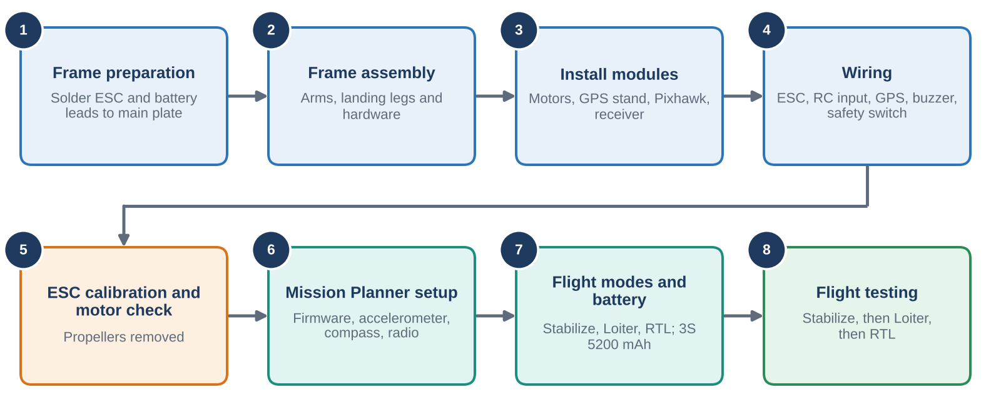
Figure 1: Overall project workflow from frame preparation to flight testing.

2. Objectives
- To assemble the mechanical frame of a quadcopter.
- To install and connect the ESCs, BLDC motors, GPS module, Pixhawk and radio receiver.
- To configure the FlySky transmitter and receiver for communication with the flight controller.
- To calibrate the ESCs, accelerometer, compass and radio controls.
- To configure battery monitoring and flight modes using Mission Planner.
- To test the drone's basic flight performance, position-holding capability and RTL functionality.

3. System Overview and Working Principle
A quadcopter has no moving control surfaces. It is steered entirely by changing the speed of its four motors. The Pixhawk reads the pilot's commands from the receiver and its own sensors (gyroscope, accelerometer, compass and GPS), calculates the speed each motor needs, and sends that command to the ESCs. The ESCs then drive the motors from the battery. Because the sensors report the result back to the Pixhawk many times per second, the loop corrects itself continuously (Figure 3).
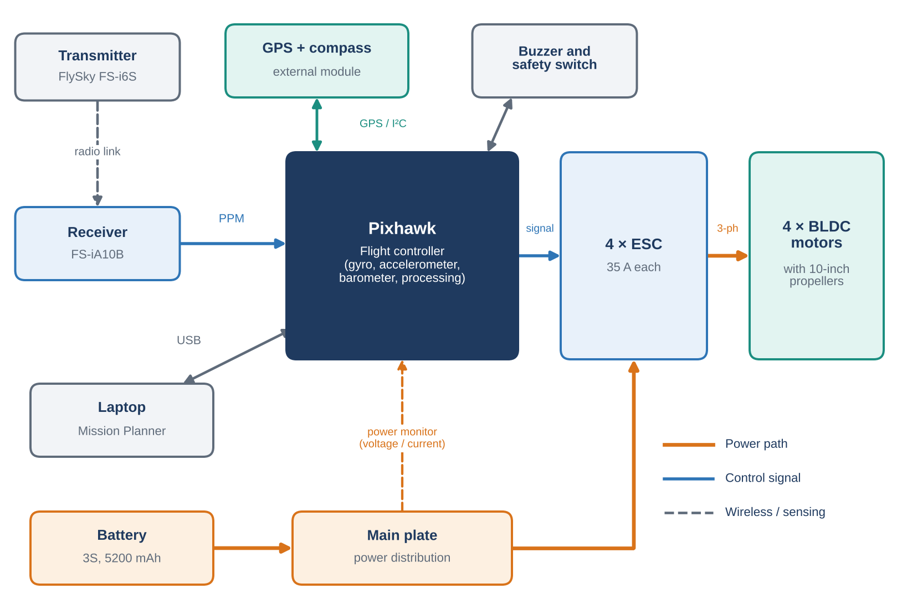
Figure 2: System block diagram showing power paths, control signals and peripherals.
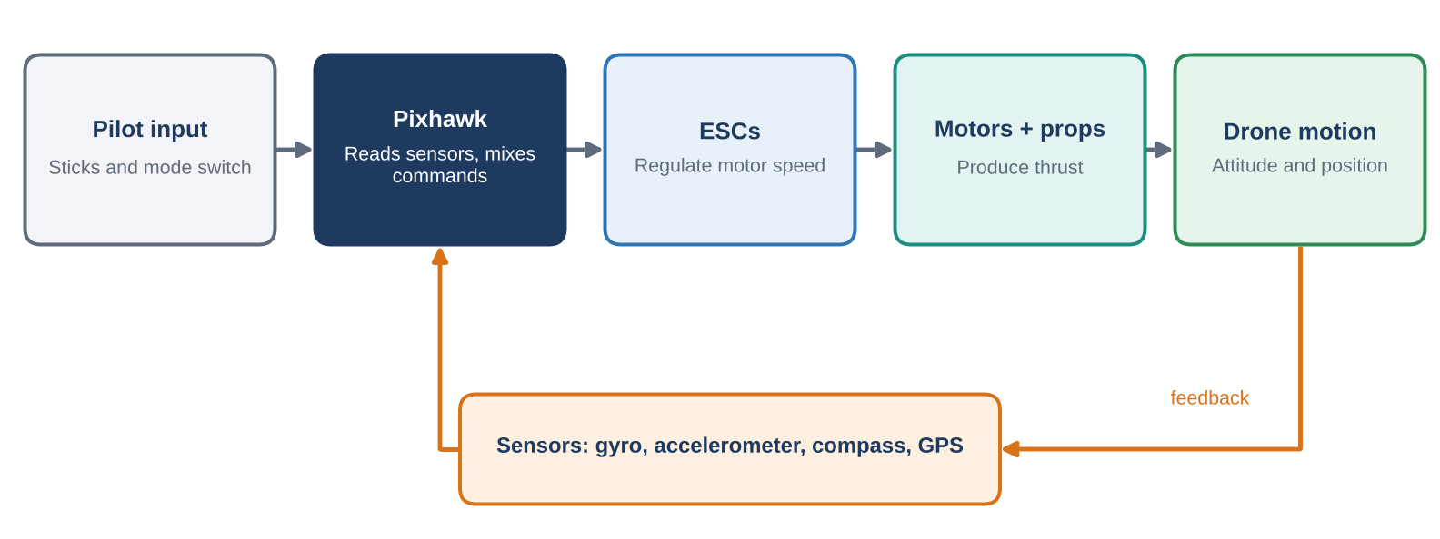
Figure 3: Closed-loop control: pilot commands and sensor feedback are combined by the Pixhawk.
The four motors are arranged so that diagonal pairs spin in the same direction. Two motors turn clockwise and two anticlockwise, so their reaction torques cancel and the drone does not spin on its own. Changing the balance between the pairs produces movement, as summarised in Table 1.
Table 1: How motor speed changes produce movement.
Pilot command | Motor speed change | Result
Throttle up | All four motors speed up | Drone climbs
Pitch forward | Rear motors speed up, front motors slow down | Nose tips down, drone moves forward
Roll right | Left motors speed up, right motors slow down | Drone tilts and moves right
Yaw | One diagonal pair speeds up, the other slows down | Drone turns on the spot

4. Components and Equipment Used
The build used a ready-made quadcopter kit based on the Pixhawk 2.4.8 flight controller, together with the FlySky FS-i6S radio system. Figure 4 shows the parts supplied for the airframe, motors, ESCs, flight controller and accessories, and Figure 5 shows the transmitter and receiver. Figure 6 identifies which Pixhawk ports were used. Table 2 lists every component.
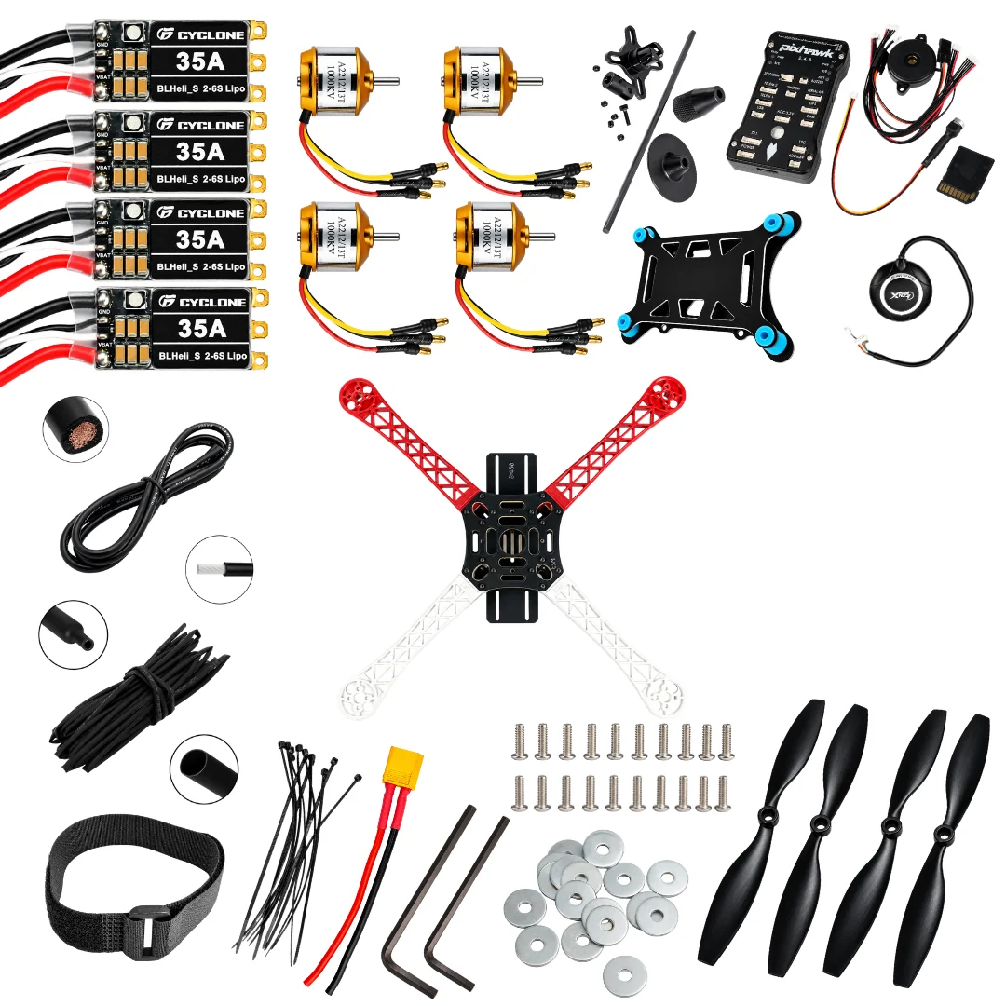  Figure 4: Parts of the quadcopter kit: ESCs, motors, Pixhawk set, GPS, frame, wiring and fasteners, propellers. | 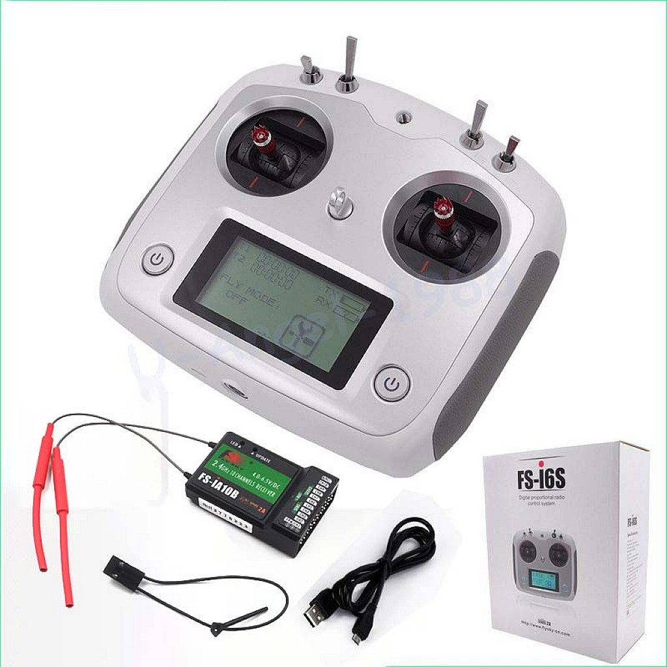  Figure 5: FlySky FS-i6S transmitter and FS-iA10B receiver with antennas and USB cable.
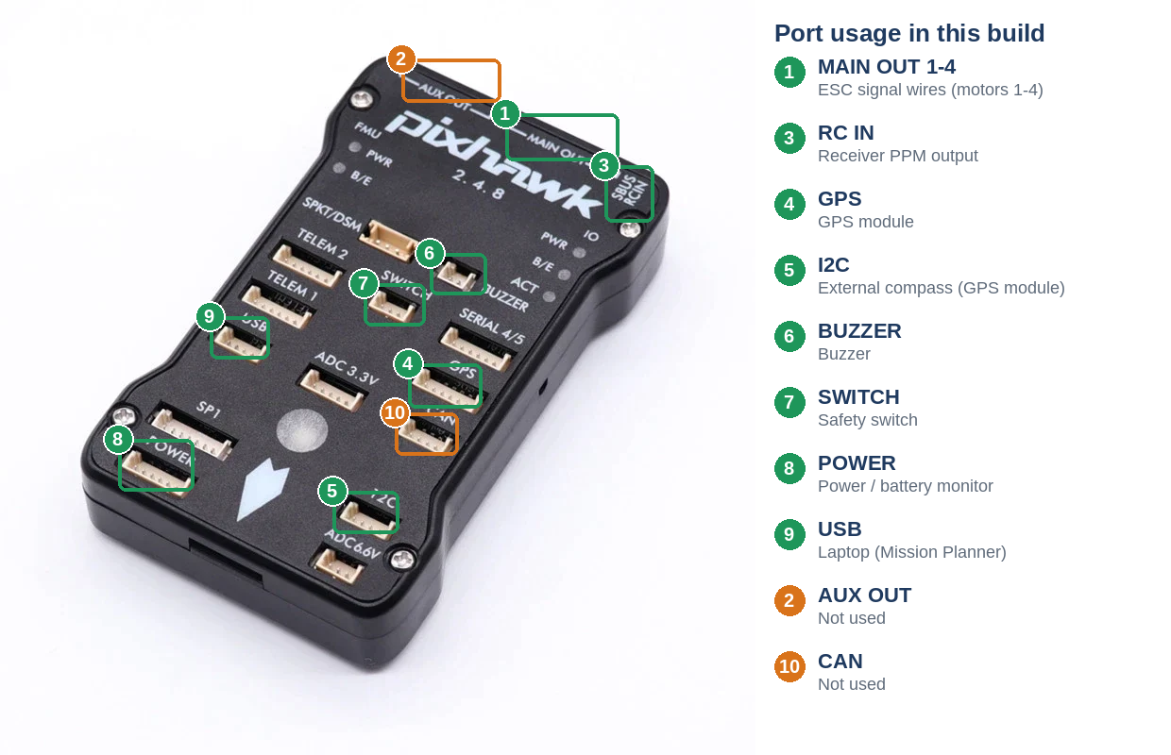
Figure 6: Pixhawk 2.4.8 with the ports used in this build highlighted in green; unused ports in orange.
Table 2: Components used in the build.
Component | Description | Role
Quadcopter frame | Four-arm frame with black main plate and landing legs; red arms mark the front and white arms mark the rear | Carries all components
Pixhawk flight controller | Pixhawk 2.4.8 with onboard sensors | Processes sensor data and pilot commands to control flight
Vibration-damping mounting plate | Black plate with blue rubber dampers | Mounts the Pixhawk and reduces vibration reaching it
BLDC motors (4) | A2212/13T, 1000 KV brushless DC motors | Generate thrust
ESCs (4) | Cyclone 35 A, BLHeli_S, rated for 2–6S LiPo | Regulate motor speed on command from the Pixhawk
Transmitter | FlySky FS-i6S digital proportional radio, with USB cable | Pilot control
Receiver | FlySky FS-iA10B, 2.4 GHz, 10 channels, 4.0–8.5 V DC, two antennas | Receives pilot commands and passes them to the Pixhawk as PPM
GPS module | GPS unit on a cable, with mast and mount (rod, base, clamp and cone); provides an external compass when fitted | Positioning for Loiter and RTL
Buzzer | Piezo buzzer on the Pixhawk cable set | Audible status and warning tones
Safety switch | Listed in the project notes | Safety switch for arming
Connecting cables | Pixhawk cable set with connectors | Link Pixhawk to peripherals
Memory card and USB cable | SD memory card and micro-USB cable | Data storage; laptop connection for Mission Planner
Battery | Reported 5200 mAh, 3-cell battery (not shown in the kit photos; confirm chemistry and rated voltage from the label) | Powers motors and electronics
Battery connector | XT60-style connector with red and black leads | Battery connection to the main plate
Propellers (4) | 10-inch black propellers, two for each rotation direction | Convert motor rotation into thrust
Wire and insulation | Silicone wire and heat-shrink tubing | Power wiring and insulation of solder joints
Fasteners and fittings | Screws, washers, cable ties and a Velcro battery strap | Assembly and cable and battery securing
Tools | Two Allen keys, soldering equipment and other hand tools | Assembly and soldering

5. Mechanical Assembly of the Drone Frame
The frame was built in the order shown in Figure 7. The electrical connections on the main plate were made first because they are much easier to reach before the arms and other parts are fitted.
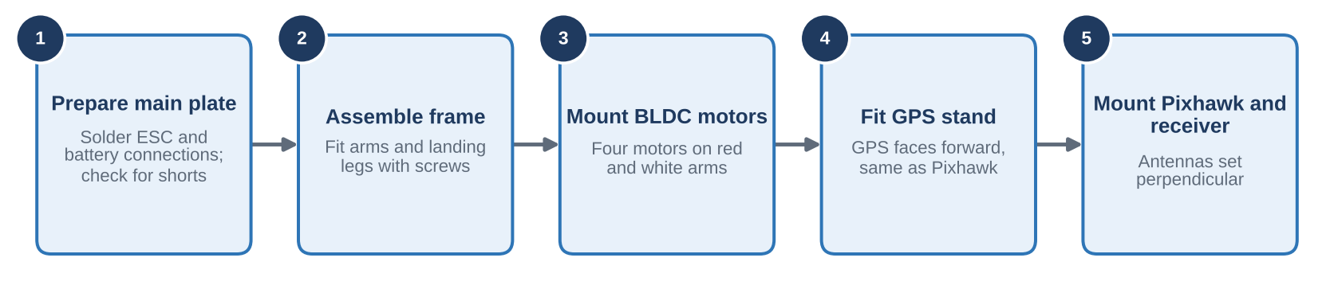
Figure 7: Mechanical assembly sequence.

Step 1: Preparation of the main plate
The ESC and battery power connections were soldered to the main plate according to the power-distribution arrangement. This was done before attaching the arms and other frame components to give better access to the electrical connections. The solder joints were checked for secure connections and possible short circuits.

Step 2: Assembly of the frame
The remaining structural components were attached with screws. The arms and landing legs were fitted to form the quadcopter structure. The red arms indicate the front of the drone and the white arms indicate the rear.
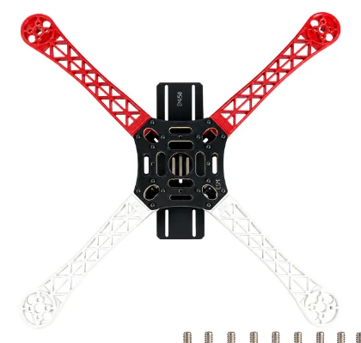
Figure 8: Frame supplied in the kit: red arms mark the front, white arms the rear.

Step 3: Installation of the BLDC motors
Four BLDC motors were mounted on the four arms using screws. Motor positions were identified from the red and white arm arrangement. Correct motor identification is necessary to match the motor order and rotation direction to the flight-controller configuration.

Step 4: Installation of the GPS module
The GPS module was attached to a separate mounting stand, and the stand was secured to the upper frame. The module was oriented forward, matching the forward direction of the Pixhawk.

Step 5: Installation of the Pixhawk and receiver
The Pixhawk and the FlySky receiver were mounted on the upper part of the frame. The receiver antennas were arranged perpendicular to each other to support radio reception.
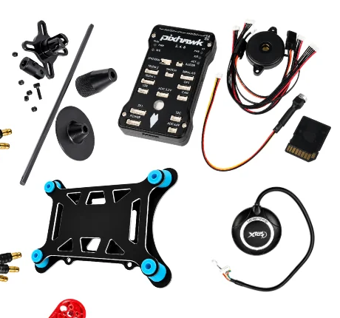
Figure 9: Parts for Steps 4 and 5: GPS module and mast mount, vibration-damping plate, Pixhawk, buzzer and cable set.

6. Electrical Wiring and Connections
The power path (battery, main plate, ESCs, motors) and the signal path (Pixhawk, ESCs, receiver, sensors) were wired separately. Figure 10 shows how each device connects to the Pixhawk, and Table 3 summarises every connection.
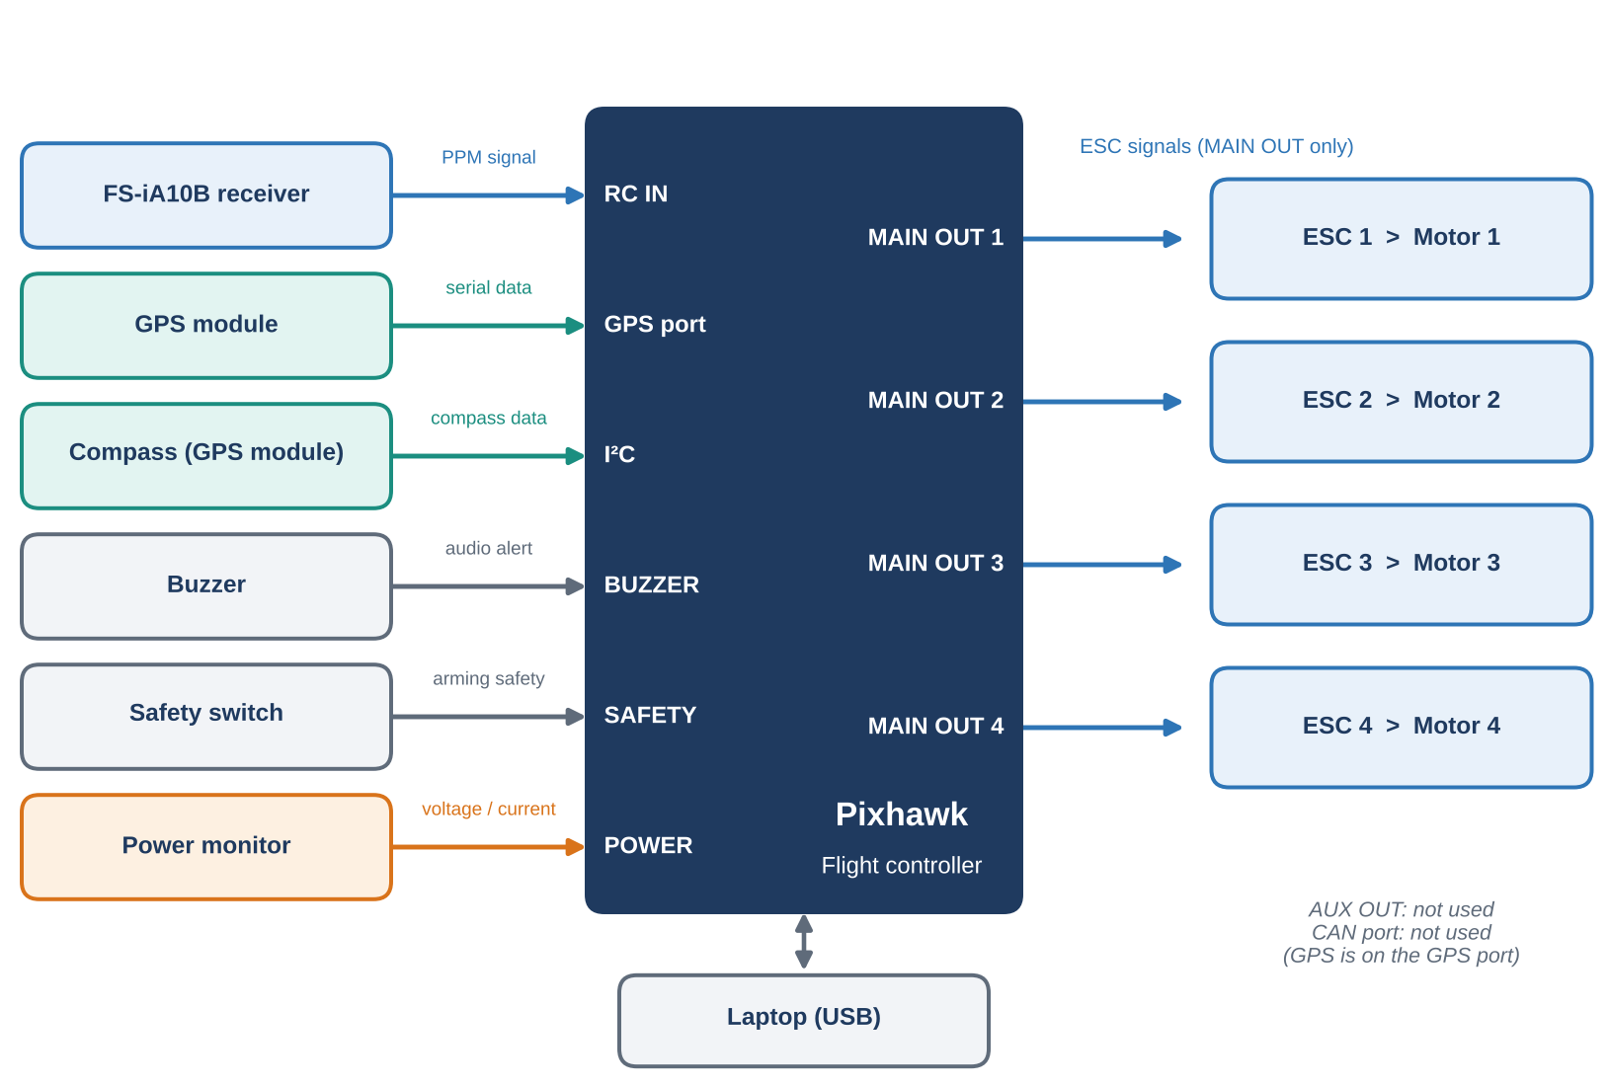
Figure 10: Connection of peripherals to the Pixhawk ports.
Table 3: Wiring summary.
From | To | Signal / port
Battery connector | Main plate | Main power
Main plate | 4 ESCs | ESC power
4 ESCs | 4 BLDC motors | Three-phase motor wires
4 ESCs (signal wires) | Pixhawk MAIN OUT 1–4 (AUX OUT not used) | ESC control signal
FS-iA10B receiver | Pixhawk RC IN | PPM
GPS module | Pixhawk GPS port | GPS data (not via CAN)
Compass (in GPS module) | Pixhawk I²C | Compass data
Buzzer, safety switch | Pixhawk buzzer and safety-switch ports | Alerts and arming safety
Power monitor | Pixhawk power port | Battery voltage / current

Step 6: ESC and battery connections
The four ESCs were connected to their corresponding BLDC motors. The ESC power connections were soldered to the main power-distribution plate, and the battery connector was connected to the power system. The wiring was inspected for correct polarity, secure solder joints and exposed conductors before the system was powered.
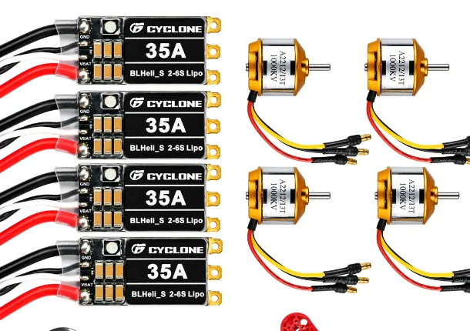
Figure 11: Cyclone 35 A ESCs and A2212/13T 1000 KV motors used in the build.

Step 7: ESC signal connections to the Pixhawk
The signal wires from all four ESCs were connected to the Pixhawk MAIN OUT channels 1 to 4, one ESC per channel. The AUX OUT pins were not used in this build. The motor outputs were assigned according to the quadcopter layout configured in the firmware.
Note: Only MAIN OUT is used for the ESCs. Motor 1 to Motor 4 correspond to MAIN OUT 1 to 4, and the exact mapping depends on the firmware and frame configuration.

Step 8: Connection of the FlySky receiver
The receiver's PPM output was connected to the Pixhawk RC IN input, allowing pilot commands to reach the flight controller. The Pixhawk processes these commands and generates the motor-control signals for the ESCs.
Note: PPM is the receiver-to-flight-controller signal format. The ESCs receive their control signals from the Pixhawk, not from the receiver.

Step 9: GPS and peripheral connections
The GPS module was connected to the designated GPS port, and its compass was connected through the I²C connection, as described for this hardware arrangement. The buzzer, safety switch and power-monitoring connections were made to their respective ports. The GPS module was not connected through the CAN port in this configuration. All connections were inspected before calibration.

7. ESC Calibration Using the Transmitter
ESC calibration teaches every ESC the same minimum and maximum throttle range so that all four motors respond identically. It was performed before the Mission Planner sensor calibrations. The main battery was connected for this stage, and the FlySky FS-i6S transmitter was used following the procedure adopted in the project (Figure 12).
Caution: All propellers must be removed during ESC calibration and motor testing.
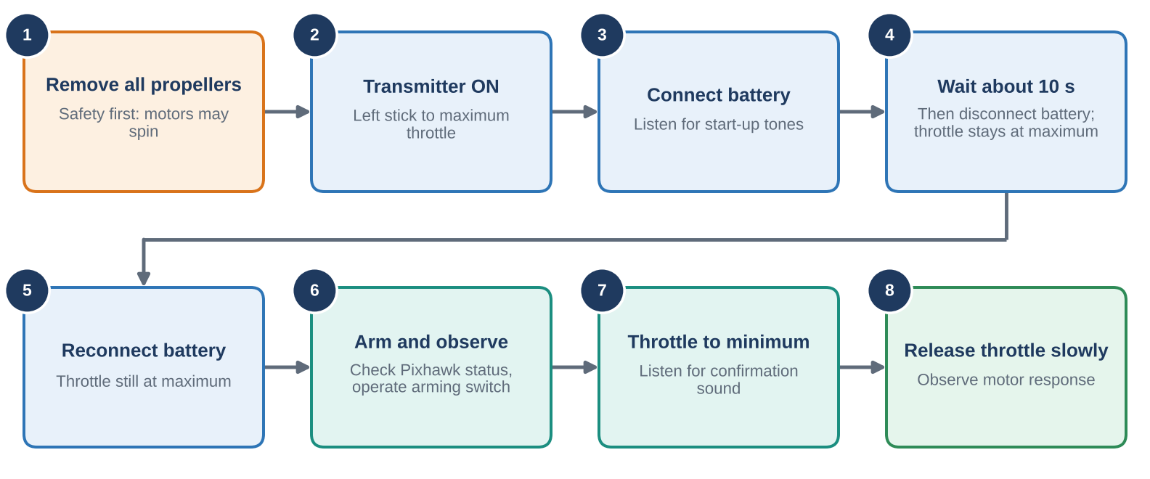
Figure 12: ESC calibration sequence using the transmitter throttle.

Step 10: Initial transmitter setup
The transmitter was switched on first, and the left throttle stick was moved to its maximum upward position. The drone battery was connected and the start-up sounds were observed. After approximately 10 seconds the battery was disconnected while the throttle remained at maximum, and was then reconnected with the throttle still at maximum, following the project procedure.

Step 11: ESC calibration and confirmation
After the battery was reconnected, the Pixhawk status indication was observed. The recorded procedure was to operate the arming switch, move the throttle to minimum and listen for a confirmation sound. The throttle was then released gradually to observe the motor response.
Note: Verify the exact sequence against the installed ESCs and Pixhawk firmware. Arming alone does not guarantee that ESC calibration has been completed.

8. Verification of Motor Rotation
The rotation direction of each motor was checked with the propellers removed. The motors follow the quad-X layout in Figure 13: diagonal motors rotate in the same direction, and the red arms mark the front. The required directions are listed in Table 4.
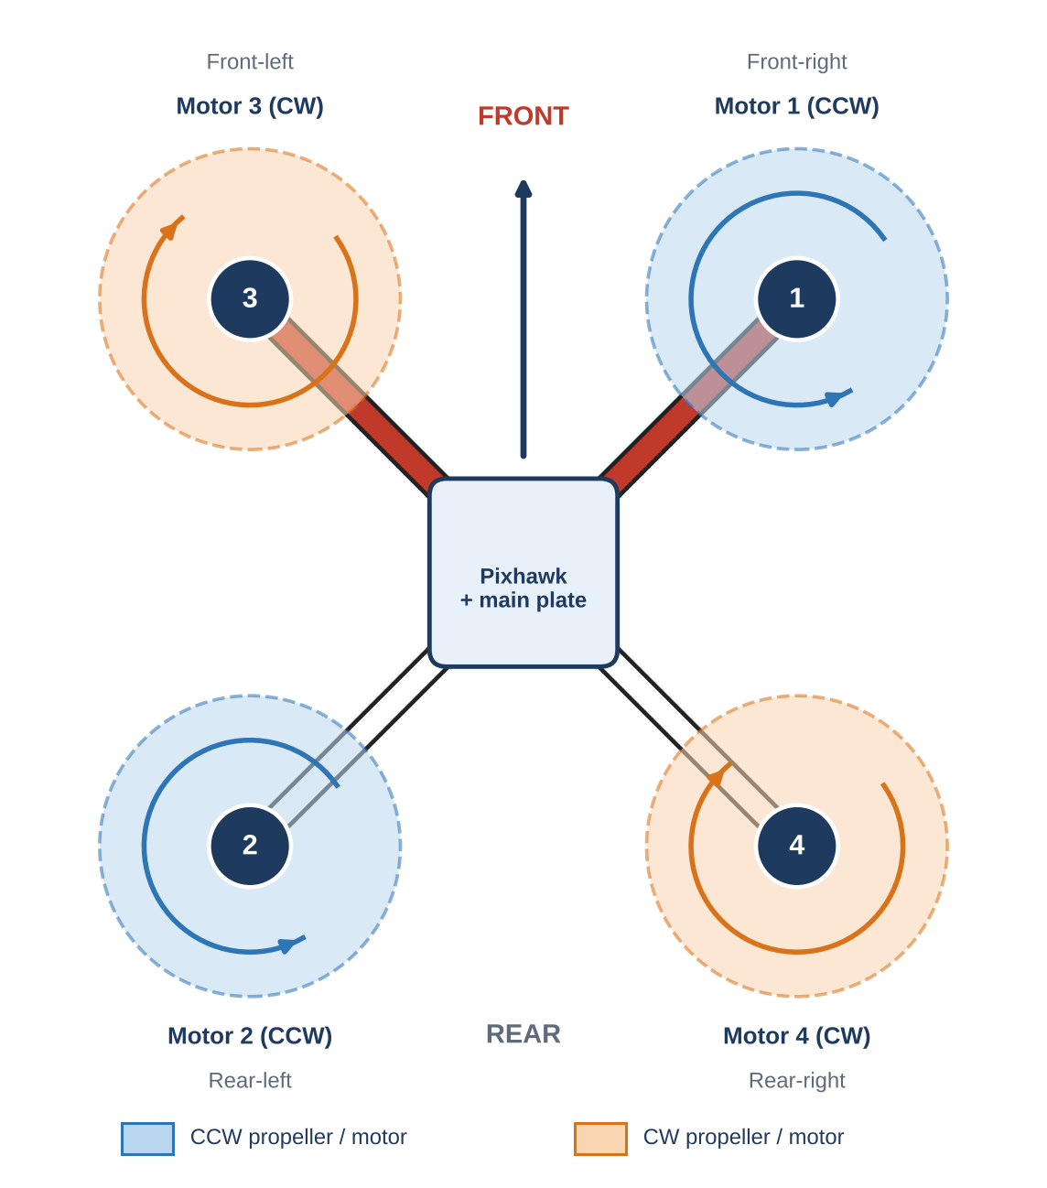
Figure 13: Quad-X motor layout showing motor numbers, positions and rotation directions (top view).
Table 4: Required motor positions and rotation directions.
Motor | Position | Arm colour | Required rotation
Motor 1 | Front-right | Red | Anticlockwise (CCW)
Motor 2 | Rear-left | White | Anticlockwise (CCW)
Motor 3 | Front-left | Red | Clockwise (CW)
Motor 4 | Rear-right | White | Clockwise (CW)
Note: Motor numbering and directions here follow the ArduPilot Quad-X convention, in which Motor 1 is front-right and diagonal motors share a direction. The exact assignment must match the frame class and type selected in the firmware, so confirm it in Mission Planner before fitting propellers.

Step 12: Checking the rotation direction
Each motor was spun at low throttle with its propeller removed, and its direction was compared with Table 4.

Step 13: Correction of incorrect motor rotation
If a BLDC motor rotated in the wrong direction, any two of the three motor phase wires between that motor and its ESC were swapped, with the battery disconnected. Swapping two phase wires reverses the direction of a conventional three-phase BLDC motor. The motor was then tested again to verify its direction (Figure 14).
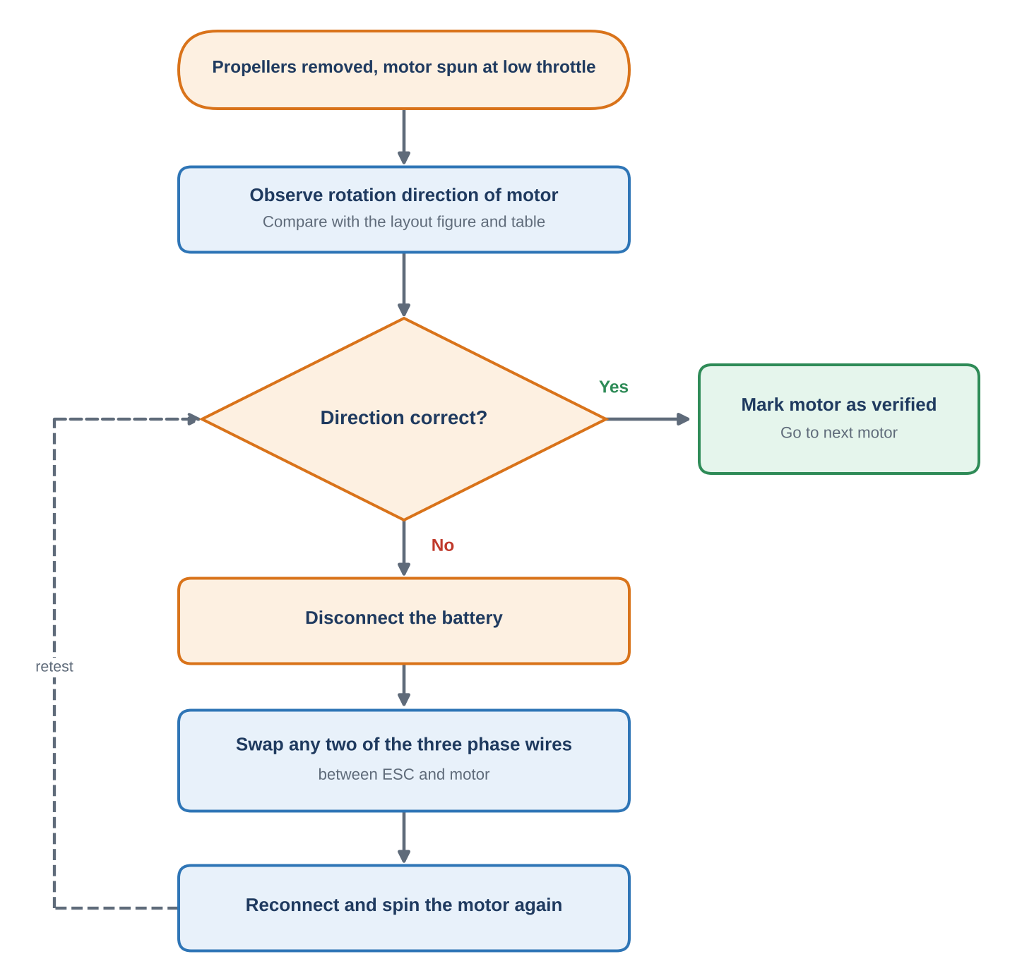
Figure 14: Procedure for checking and correcting motor rotation.

9. Mission Planner Software Setup
After the hardware checks, the flight controller was configured in Mission Planner. The configuration steps were carried out in the order shown in Figure 15, which also indicates where the later sections of this report apply.
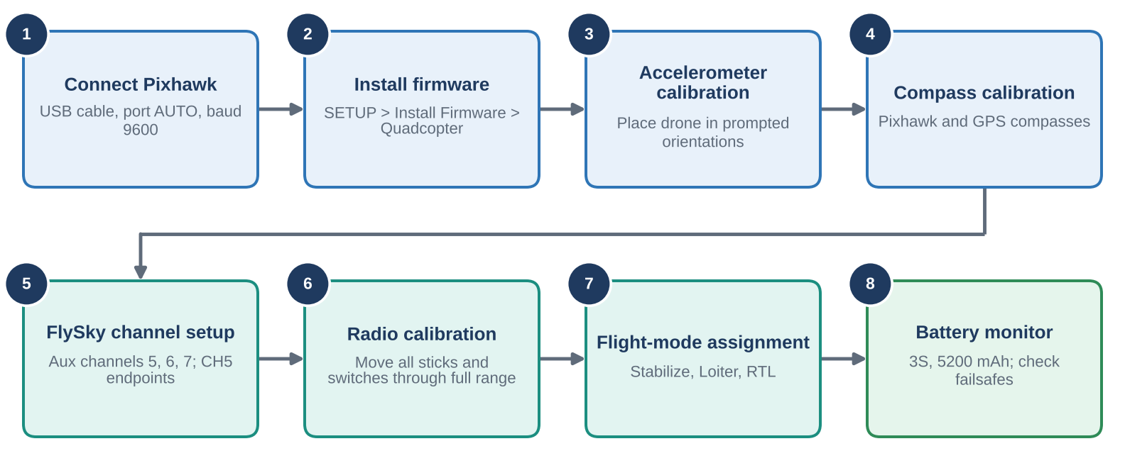
Figure 15: Mission Planner and transmitter configuration sequence.

Step 14: Connecting the Pixhawk to Mission Planner
The Pixhawk was connected to a laptop using a USB cable. Mission Planner was opened, the communication port was set to AUTO and the baud rate was set to 9600 according to the project procedure. Communication was established, and sensor information, including gyroscope readings, was observed on the DATA screen.
Note: USB connection and baud-rate requirements can vary by interface and firmware.

Step 15: Firmware installation
The firmware installation option was opened under SETUP in Mission Planner. The vehicle type was selected as quadcopter and the appropriate firmware was installed for the Pixhawk hardware. The vehicle configuration was checked before calibration.

10. Accelerometer Calibration
Accelerometer calibration tells the Pixhawk what "level" is and corrects sensor offsets, so the drone can hold a stable attitude. Mission Planner asks for the drone to be placed in a series of orientations (Figure 16).
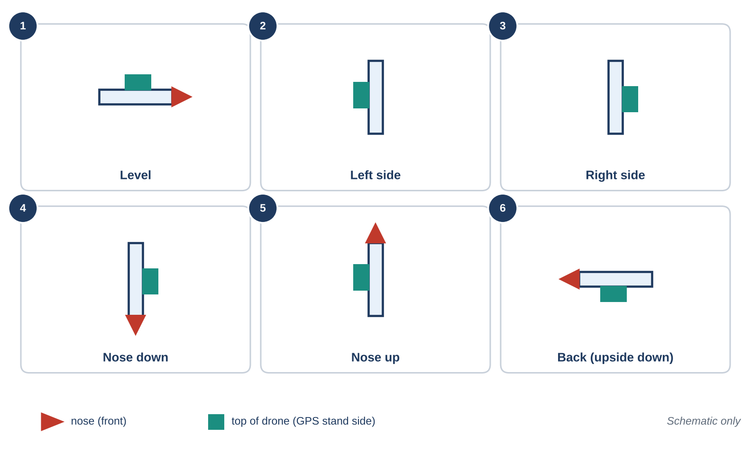
Figure 16: Orientations requested during accelerometer calibration (schematic).

Step 16: Calibration procedure
The accelerometer calibration option was opened in Mission Planner. The drone was placed in each orientation requested by the software, including level, left and right sides, nose-down, nose-up and back, as prompted. Each position was held steady until the software registered the measurement, and the procedure was completed following the on-screen instructions.
Caution: Use a stable surface and keep the drone stationary during each measurement. Accelerometer calibration does not need a GPS fix, but outdoor testing is important for GPS and compass checks because GPS reception may be poor indoors.

11. Compass Calibration
The compass gives the drone its heading. Calibration removes the effect of magnetic fields from nearby metal and wiring, and is essential for reliable Loiter and RTL behaviour.

Step 17: Selecting the compass units
The compass calibration section of Mission Planner was opened. Two compass units were selected: the compass associated with the Pixhawk and the external compass integrated into the GPS module, subject to the installed hardware and configuration.

Step 18: Compass calibration procedure
The drone was rotated through multiple orientations to collect compass measurements, following the sequence in Figure 17: about two clockwise turns while level, the same while vertical, and then rotation with the drone on its right side, left side, nose-down and fully upside-down. Calibration progress was monitored in the software.
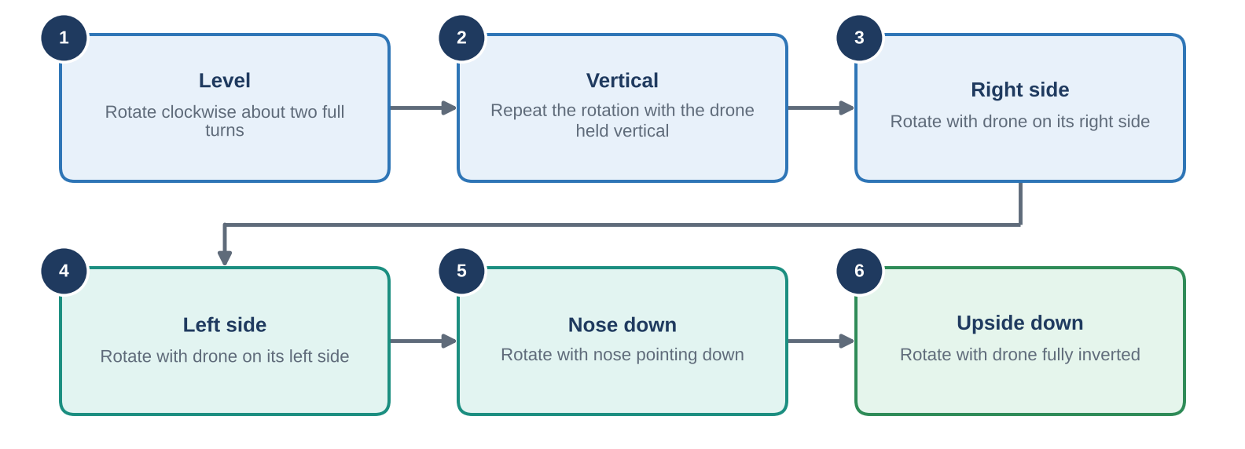
Figure 17: Compass calibration orientation sequence.
Note: Follow the prompts displayed by the installed Mission Planner version.

12. FlySky Transmitter Configuration and Radio Calibration

Step 19: Auxiliary channel configuration
The FlySky FS-i6S auxiliary-channel settings were opened. The recorded configuration used Channels 5, 6 and 7. The SWB three-position switch was assigned to Channel 5, and the other auxiliary channels were set according to the intended control arrangement. The required switches were placed in their upper positions before starting the setup.
Note: Verify the exact channel mapping using the transmitter channel monitor and Mission Planner.

Step 20: Channel 5 endpoint settings
Table 5: Channel 5 endpoint settings.
Parameter | Recorded setting
Upper endpoint | 80%
Lower endpoint | 52%
Note: These values were retained from the transmitter configuration used in the project. Check them against the actual transmitter menu, because endpoint percentages and PWM values are not interchangeable.

Step 21: Radio calibration in Mission Planner
The radio calibration screen was opened. The transmitter sticks and assigned switches were moved through their full ranges so that Mission Planner could detect the channel limits. Calibration was confirmed in the software, and the displayed channel values were checked to ensure that they changed as the controls were moved. The main flight battery remained disconnected during this calibration.

13. Flight-Mode Configuration
One three-position switch (SWB on Channel 5) selects the flight mode. The receiver passes the switch position to the Pixhawk, which compares it with the mode settings stored in Mission Planner (Figure 18).
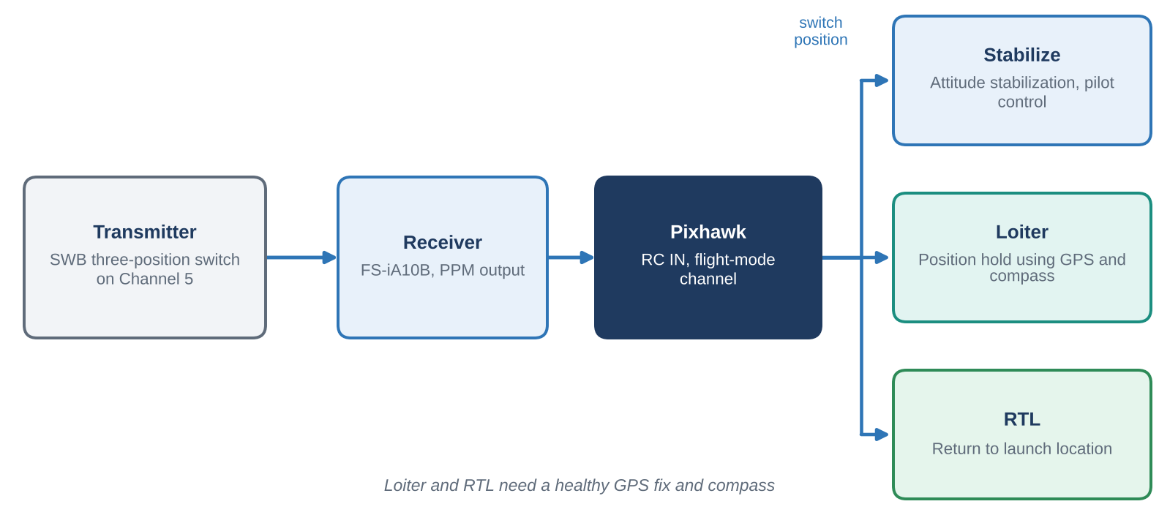
Figure 18: Flight-mode selection chain from the transmitter switch to the Pixhawk.

Step 22: Assigning the flight modes
The flight-mode configuration section in Mission Planner was opened. The assigned transmitter switch was moved through its positions and the displayed mode was observed. The switch positions were checked to confirm that the intended modes appeared in Mission Planner. The main battery was kept disconnected during this procedure.
Table 6: Configured flight modes.
Flight mode | Function
Stabilize | Provides attitude stabilization while allowing the pilot to control the drone.
Loiter | Uses suitable position estimates to help maintain position while allowing controlled movement.
RTL (Return to Launch) | Commands the drone to return to its configured home location according to the navigation and RTL settings.

14. Battery and Propeller Configuration

Step 23: Battery-monitor configuration
Table 7: Battery specification.
Parameter | Project specification
Capacity | 5200 mAh (5.2 Ah)
Cell configuration | 3S
Chemistry | Reported as lithium-ion; verify from battery label
Nominal voltage | Approximately 11.1 V for a conventional 3S lithium-ion pack
Fully charged voltage | Typically 12.6 V for cells charged to 4.2 V each
Battery-monitor parameters were to be configured in Mission Planner according to the installed power-monitor hardware, and the battery failsafe parameters were also to be checked. Battery voltage and current monitoring depend on the power module and its calibration.

Step 24: Propeller identification
The drone used 10-inch propellers. The markings discussed were 10-45 R and 10-45. The number 10 commonly indicates a 10-inch diameter, and 45 typically indicates a 4.5-inch pitch.
Caution: Marking conventions vary by manufacturer, and the letter R does not universally indicate anticlockwise rotation. Confirm the intended direction from the manufacturer and the blade geometry. Fit propellers only after confirming motor order, rotation and firmware configuration.

15. Final Preparation Before Flight

Step 25: Initial system start-up
After configuration and calibration the USB cable was disconnected, the drone was taken to a suitable outdoor testing area and the battery was connected. Start-up sounds and status indicators were observed. The recorded sequence was an initial red LED, followed by yellow with a blinking green LED, and then a more stable indication after approximately 10 seconds (Figure 19).
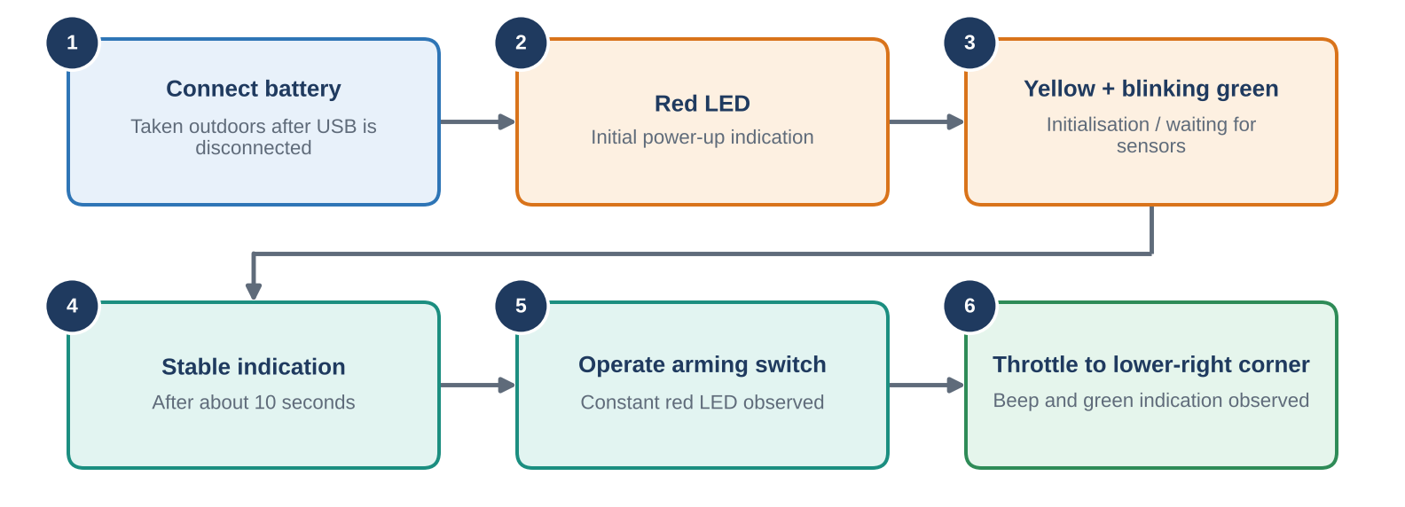
Figure 19: Start-up and arming sequence observed during the project.

Step 26: Arming and motor-start checks
The configured arming switch was used and the status indicator was observed. The project notes describe a constant red LED after arming. The left throttle stick was then moved to the lower-right corner, as used in this particular setup, and a beep and green indication were observed.
Note: LED meanings depend on the Pixhawk model, firmware and peripherals, and these observations are specific to this project. Confirm the correct arming procedure and ready-to-arm status for the installed firmware before take-off.

16. Flight Testing and Observations
Flight testing proceeded from the simplest mode to the most automated one (Figure 20), so that each mode could be checked before relying on the next.
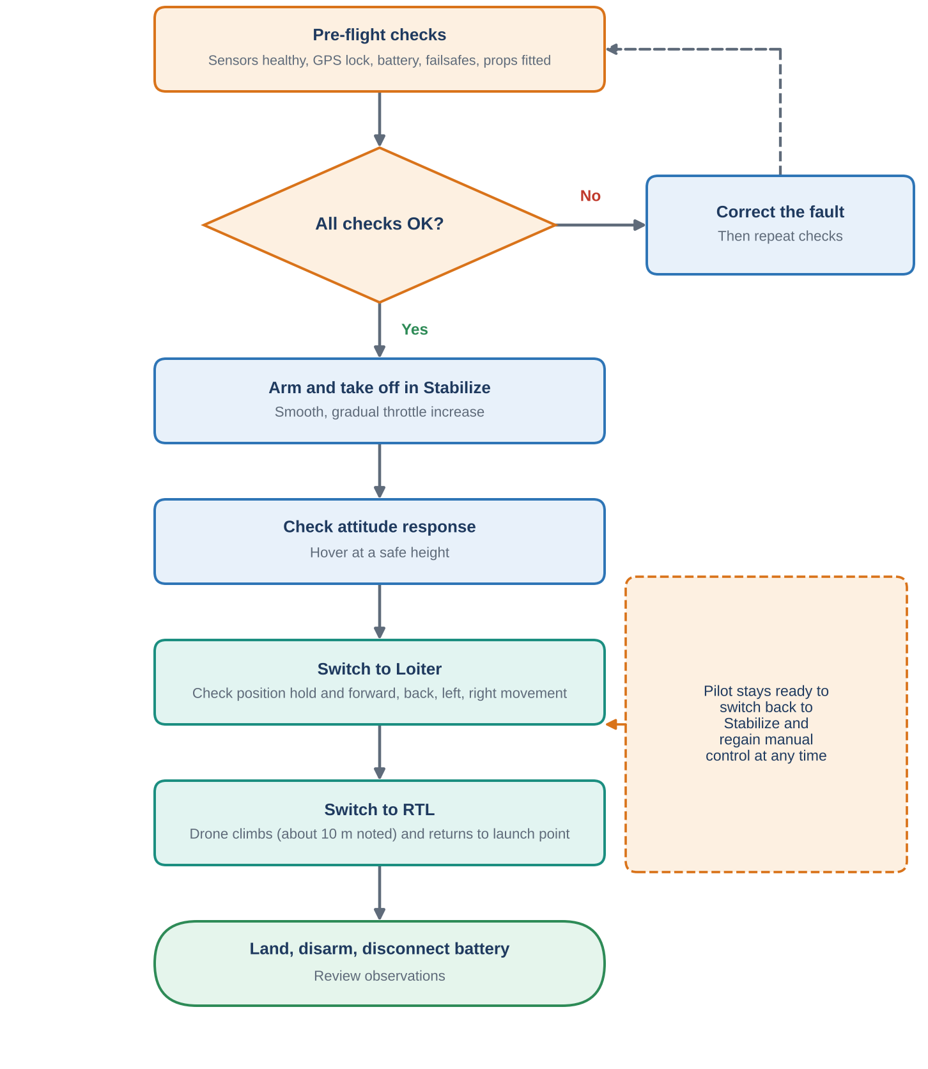
Figure 20: Flight-test sequence: Stabilize, Loiter, then RTL.

Step 27: Initial flight in Stabilize mode
The initial flight was conducted in Stabilize mode. The pilot gradually increased throttle to achieve a controlled take-off and checked the drone's basic attitude response. Throttle adjustments should be smooth and controlled, and the first take-off should take place only after all safety checks are satisfactory.

Step 28: Testing Loiter mode
After reaching a suitable height, the flight-mode switch was moved from Stabilize to Loiter. The purpose was to check position-holding behaviour and controlled forward, backward, left and right movement. Loiter requires a reliable position estimate and suitable GPS and compass performance.

Step 29: Testing RTL mode
At the end of the flight test the mode was switched to RTL. The expected behaviour was for the drone to navigate back to its configured launch location. The project notes describe an ascent to approximately 10 metres before returning.
Caution: The actual RTL altitude and path depend on the configured parameters, firmware and flight conditions. The pilot should monitor the drone and be prepared to regain control if necessary.

17. Safety Precautions

Before powering the system
- Disconnect the main flight battery before soldering, modifying wiring or changing motor phase connections.
- Check battery polarity, solder joints, ESC connections and power-monitor wiring before connecting the battery.
- Check motor order, rotation direction and propeller compatibility before flight.

During calibration and configuration
- Keep all propellers removed during ESC calibration, sensor calibration and motor-rotation testing.
- Keep the main battery disconnected during Mission Planner accelerometer, compass, radio and flight-mode configuration, except for procedures that specifically require battery power.
- Follow the ESC manufacturer's calibration instructions and the flight controller's documented procedure.
- Confirm GPS and compass orientation and verify that sensor status is healthy.

Before and during flight
- Verify radio failsafe, battery failsafe, arming conditions and RTL configuration before the first flight.
- Conduct initial flight testing in a clear, suitable outdoor area with people kept away from the drone.
- Follow applicable drone operating requirements and use an experienced operator for initial flight testing.

18. Troubleshooting Guide
Table 8: Common problems and suggested actions.
Symptom | Possible cause | Suggested action
Motor spins in the wrong direction | Phase wires in the wrong order | With the battery disconnected, swap any two phase wires and retest
Motors respond unequally to throttle | ESCs not calibrated together | Repeat ESC calibration with propellers removed
Drone will not arm | Safety switch not pressed, pre-arm check failing, radio not calibrated | Check Mission Planner messages, safety switch and radio calibration
Mission Planner will not connect | Faulty USB cable, wrong port or baud rate | Try another cable, select the correct port and check the baud rate
Mode switch does not change the mode | Channel 5 range or mapping incorrect | Check the channel monitor and repeat radio calibration
Loiter or RTL does not work well | Poor GPS fix or uncalibrated compass | Fly outdoors with a clear sky view and repeat compass calibration
Drone flips or yaws at take-off | Wrong motor order or propeller direction | Re-check the motor layout and propeller markings before the next flight

19. Conclusion
The project involved assembly and configuration of a quadcopter using a Pixhawk flight controller, four BLDC motors, four ESCs, a GPS module, and a FlySky FS-i6S radio-control system with an FS-iA10B receiver. The main plate was prepared first, followed by frame assembly, motor installation, GPS mounting and wiring of the flight controller and receiver. ESC calibration and motor-rotation checks were then performed before Mission Planner configuration.
The subsequent stages included firmware installation, accelerometer calibration, compass calibration, radio calibration, battery-monitor configuration and flight-mode assignment. Stabilize, Loiter and RTL were selected for testing basic flight control, position-holding capability and return-to-launch functionality. The project provided practical experience in drone assembly, electrical wiring, flight-controller configuration, sensor calibration, radio communication and basic autonomous navigation. Safe operation requires verification of hardware-specific settings and completion of all pre-flight checks.

20. Future Scope
- Add a telemetry radio for live monitoring and parameter changes in flight.
- Tune the flight controller further (for example, with an auto-tune procedure) for smoother handling.
- Plan and fly autonomous waypoint missions in Mission Planner.
- Add a camera or gimbal payload and measure the effect on flight time.
- Log flights and analyse the logs to evaluate vibration, battery performance and RTL accuracy.

Appendix: Items to Verify Before Final Submission
Done | Item to verify
☐ | Pixhawk firmware version (the board is a Pixhawk 2.4.8).
☐ | Battery label confirming chemistry, cell count, voltage and capacity.
☐ | Exact GPS/compass model and port arrangement (GPS port and I²C).
☐ | Exact propeller manufacturer and rotation markings.
☐ | Correct motor numbering and rotation diagram for the configured frame (Figure 13 and Table 4).
☐ | ESC calibration method recommended for the installed ESC model.
☐ | Transmitter channel mapping and Channel 5 endpoint settings.
☐ | Actual RTL altitude configured in Mission Planner.

